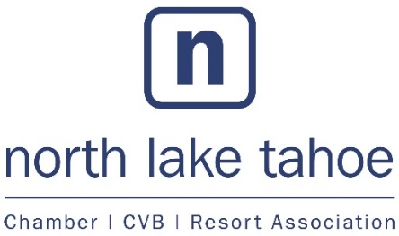

2022 TOURISM DEVELOPMENT Committee Members

NLTRA BOARD MEMBERS
Ray Villaman
Owner
Tahoe Restaurant Group
Ph: 530.448.9333
raytrg@yahoo.com

COMMITTEE MEMBERS
Adam Wilson  Sr. Director of Sales  Vail Resorts  Ph. 530.448.1807  APWilson@vailresorts.com | Becky Moore, Vice Chair  Director of Sales and Marketing  Granite Peak Management  Ph. 530.583.5500 ext. 4013  beckym@gpeak.com | Brit Crezee  Director of Marketing  Sierra Sotheby’s  Ph. 530.412.1477  bcrezee@sierrasothebysrealty.com
Carlynne Fajkos, Chair  Owner  Tahome Marketing  Ph. 415.525.7397  carlynne@tahomemarketing.com | Caroline Craffey  Communications Manager  Tahoe Truckee Community Foundation  Ph.530.587.1776  caroline@ttcf.net | Christine Horvath  Marketing Director  Palisades Tahoe  Ph.800.403.0206  chorvath@palisadestahoe.com
Connor McCarthy  Resort Services & Business Solutions Director  Homewood Mountain Resort  Ph.530.584.6806  cmccarthy@skihomewood.com  Melissa Burin  Senior Marketing Manager  The Ritz-Carlton, Lake Tahoe  Ph. 847.436.3586  Melissa.Burin@marriott.com | Kressa Olguin  Marketing Manager  Hyatt Regency, Lake Tahoe  Ph.775.605.8333  Kressa.olguin@hyatt.com  Vinton Hawkins  General Counsel, Project Manager  MJD Capital  The Boatworks at Lake Tahoe  Ph. 916.642.5487  vinton@mjdcp.com | Kristy Olk  Senior Sales Manager  The Resort at Squaw Creek  Ph. 530.584.4093  Kristy.Olk@destinationhotels.com  Wendy Hummer  Owner  EXL Media  Ph. 775.832.0202 x.101  wendy@exlmedia.com

