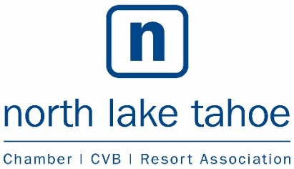
Mission of the North Lake Tahoe Chamber of Commerce
“To take specific actions to help improve the opportunity for local businesses to achieve and sustain success: to promote business, tourism, and the economic, cultural and civic welfare of the greater North Lake Tahoe community.”

[Cite your source here.]
BUSINESS ASSOCIATION AND
CHAMBER COLLABORATIVE (BACC)
Date: Thursday, June 13, 2019
Time: 1:00pm
Location: Tahoe City Visitors Information Center,
100 North Lake Blvd., Tahoe City, CA 96145

Committee Members: Chair: Caroline Ross, Squaw Valley Business Association
Stephen Lamb, PlumpJack Inn | Kylee Bigelow, Tahoe City Downtown Association
Joy Doyle, North Tahoe Business Association | Jody Poe, North Tahoe Business Association
Greg Long, Incline Village Crystal Bay Visitors Bureau | Paul Raymore, IVGID/Diamond Peak Ski Resort
Kay Williams, West Shore Association | Travis Mraz, West Shore Cafe
Liz Bowling, North Lake Tahoe Resort Association I North Lake Tahoe Resort Association Board Member: Jim Phelan
North Lake Tahoe Resort Association Board Member Alternates: Karen Plank/Aaron Rudnick
Placer County Representative: Erin Casey/Emily Setzer
AGENDA

TO CALL IN: 1-712-451-0011, access code: 871234

1. Call to Order – Establish Quorum

2. Public Forum-Any person wishing to address the BACC on items of interest to the committee not listed on the agenda may do so at this time. It is requested that comments be limited to three minutes since no action may be taken by the committee on items addressed under Public Forum.

3. Agenda Amendments and Approval – MOTION

4. Approval of Meeting Minutes
- Thursday, April 25, 2019 – MOTION

Discussion & Strategy:
5. TBID Education & New Developments – Rob Kautz (25 minutes)

6. NLTRA Update – Liz Bowling (10 mins)
a. Chamber Programming
c. Summer Visitor Guide
d. NLTRA.org to business members

7. Summer Initiatives, Talking Points, Cross Promotion – Business Association Leads (40 minutes)

8. Future Meeting Dates – Liz Bowling (5 minutes)
In-Market Tourism Development: Tuesday, September 24 @ 1pm @ Tahoe City PUD
BACC: Thursday, August 8 @ 1pm @ NLT Visitor Center

Other Items:
9. Committee Member Reports/Updates from Community Partners (1-2 mins each)

10. Adjournment

This meeting is wheelchair accessible Posted online at www.nltra.org

