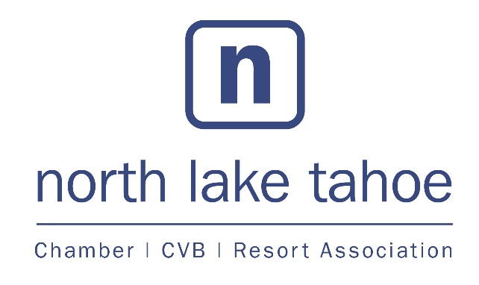
2019 Sponsorship Opportunities

First Tuesday Breakfast Club
First Tuesday Breakfast Club is a community forum presented by the North Lake Tahoe Resort Association/Chamber of Commerce. Gathering up to 60 community members per meeting, this monthly event covers a broad range of topics from a variety of presenters.
Occurs Monthly on the First Tuesday at Granlibakken Tahoe Resort, 7 – 8:30 AM
$500 Sponsorship Fee includes:
- Advertising: one ad twice per month in Sierra Sun with business logo included (value: $5,530)
- Listed and tagged on promotional materials: press release, social media posts, eventbrite, website
- Bi-Annual Planning Meeting to determine speakers and themes for the year
- One Breakfast Club ticket per month
- Sponsor recognition at Breakfast Club
Business Seminars & Workshops
With a goal of empowering team members and promoting a culture of learning, the Chamber of Commerce hosts a variety of training seminars and workshops to sharpen skills and explore new tactics, technologies and leadership growth.
The Chamber hosts seminars as training needs and requirements arise; three seminars are hosted annually in conjunction with North Tahoe Business Association and Tahoe City Downtown Association.
Trainings, business seminars and workshops are promoted on the Chamber’s social media channels, through e-communications and NLTRA Blog, and on the events calendar. Sponsorship levels start at $350. Fee includes:
- Logo inclusion on all collateral materials
- Listed and tagged on promotional materials: press release, social media posts, eventbrite, website
- Ability to introduce speaker/topic, bring collateral materials to training
- Custom packages available

